PLEASE MAKE TWO TABS ON THIS PAGE - www.shiptekmaritimeevents.com
IT SHOULD BE SIMILAR TO WHAT YOU DID FOR AIMTEK (REFERENCE) - https://www.aimtekme.com/

PLEASE CREATE A TABS – SHIPTEK DUBAI 2024 AND ANOTHER TAB - SHIPTEK KSA 2024

For ShipTek KSA website, please use the below content. We need to use the colours – white and green for KSA website.

- Above home page, please put 2023 highlights video. Share specs in what size and mb you need.

- Countdown and Event date to be added 4th – 5th June 2024. Location: KSA. Please do similar to what is done in ShipTek Dubai 2024

- Also need to place the 4 tabs on homage –
- Sponsorship enquiry
- Delegate Registration
- Nomination Registration
- Media Registration

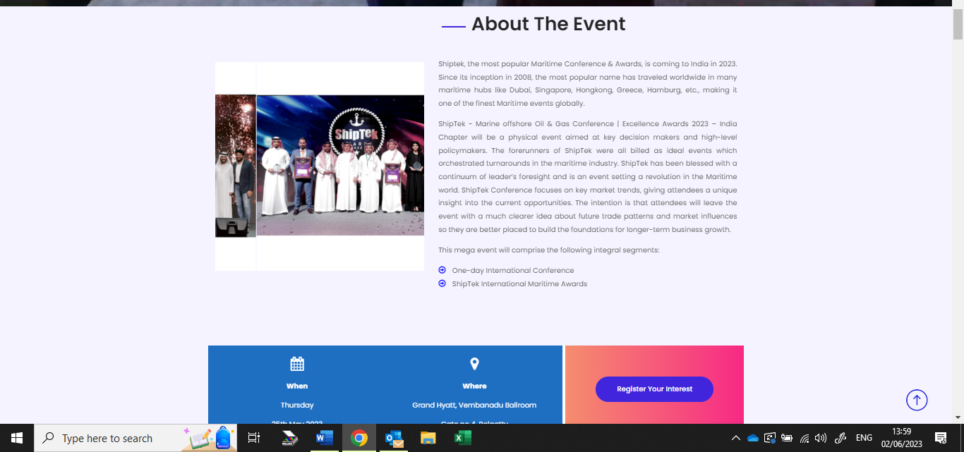

About The Event
WHY SAUDI ARABIA.?
Saudi Arabia possesses around 18 per cent of the world’s proven petroleum reserves and ranks as the world ‘second largest of crude reserves. It also has the fifth-largest proven natural gas reserves. Saudi Arabia is a Founder Member of OPEC with total resource valued at $ 34.4 trillion to become the third country after Russia and the US to have the most plentiful and valuable natural resources. Saudi Arabia ranks among the best G20 economies.
Saudi Arabia embarked on amazing journey by introduced sweeping and impressive economic reforms aimed at moving the country away from its dependence on oil in 2016. As part of its ambitious vision 2030, the kingdom developed strategies to diversify non-oil revenues.
The KSA Government implemented reforms that made starting a business easier by establishing a one-stop shop, introduced a secured transactions law, insolvency law Protecting Minority Investors and measures were taken to empower more women to join the workforce.

About ShipTek KSA
ShipTek International Conference & Awards KSA 2024 – MARINE/OFFSHORE/OIL&GAS will be a physical event aimed at key decision makers and high-level policymakers This two-day event will bring together industry leaders, organizations, suppliers and experts for networking and business tie-up opportunities.
Since its inception in 2008, this most popular name SHIPTEK in the maritime industry has traveled worldwide - Dubai, Singapore, Hongkong, Greece, Hamburg, India etc. making it one of the finest maritime events globally.
This mega event will comprise the following integral segments:
- Two-days International Conference on Marine/Offshore/Oil&Gas
- ShipTek International Awards KSA 2024

SHIPTEK INTERNATIONAL CONFERENCE KSA– TOPICS 2024

The conference topics cover a range of subjects related to the Marine, Offshore, Oil & Gas Industry including Technological Advancements, Environmental Considerations, Safety, Sustainability, and various operations. The presentations will aim to address Current Challenges, Share Knowledge and discuss future opportunities in the sector.
PRESENTATION TOPICS WILL COVER -
- Green Shipping: Decarbonization Strategies and Technologies
- Digitalization in Maritime Operations: From Smart Ports to Blockchain
- ESG (Environmental, Social, and Governance) in OFFSHORE/ Oil & Gas
- Marine Robotics and Autonomous Systems in Offshore Applications
- Energy Transition: The Role of Oil & Gas in a Low-Carbon Future
- Port Infrastructure DEVELOPMENT:EXPANSION & Modernization Projects
- CREW Well-being: Promoting Crew Welfare & Mental Health
- ALTERNATIVE SHIP FUELS – CURRENT STATUS & OUTLOOK
- CLASSSIFICATION SOCIETY – RULES, REGULATIONS & RECOMMENDATIONS
- MARITIME REGULATIONS & GOALS - TODAY / 2030
- Subsea Engineering and Innovations in Deepwater Operations
- Marine and Offshore Environmental Monitoring and Compliance
- Sustainable Energy Solutions for the Oil & Gas Industry
- Advances in Offshore Drilling Techniques and Equipment
- Future Trends in Shipbuilding and Naval Architecture
- Maritime Safety and Risk Management: Lessons from Recent Incidents
- Port Automation & Optimization: Enhancing Efficiency & Performance
- Maritime Law & Regulations: Navigating Legal Challenges in the Industry
- Sustainable Practices in Upstream, Midstream,Downstream Operations
- LNG Bunkering and Infrastructure for Sustainable Marine Transportation
- Maritime Training & Workforce Development: Bridging the Skills Gap
- Offshore Wind Energy: Opportunities and Challenges

SHIPTEK INTERNATIONAL AWARDS KSA - 2024
ShipTek International Awards KSA - 2024 is back to celebrate the remarkable & noteworthy contributions of the Individuals/Organizations In the maritime/ Offshore/Oil&Gas/Port & Logistics sectors. A proud symbol of celebration & recognition, the award ceremony gained its popularity and credibility through its forerunners. The award ceremony shall be organized in concurrence with ShipTek International Conference. So don’t wait and miss out to place your nomination for the respective category and be a participant in the final race among other top organizations & individuals
Become a part of this Grand Evening of Recognition where Excellence Matters..!!

- Best HSE Initiatives.
- Sustainable Organization of the Year
- Best Employer of the Year
- Ship Repair Yard of the Year
- Best Training Institute
- Offshore Project of the Year
- Green Shipping Award
- Tanker Operator of the Year
- Ship Operator of the Year
- CSR Award of the Year
- Best Ship Agency of the Year
- Port of the Year
- Best Project - Innovation
- Best Classification Society of the Year
- Ship Manager of the Year
- New Building Yard of the Year
- Rising Star – Organization
- Rising Star - Individual
- Law firm of the Year
- Young Women Achiever of the Year
- Offshore Industry Leader of the Year Award
- Best Service Provider - Marine
- Best Service Provider - Offshore
- Best Service Provider - Oil & Gas
- Best Maritime Association
- CEO of the Year
JURY AWARDS -
- ShipTek – Women Personality of the Year
- ShipTek - Maritime Personality of the Year
- ShipTek Life Time Achievement Award - Entrepreneur
- ShipTek Life Time Achievement Award - Services

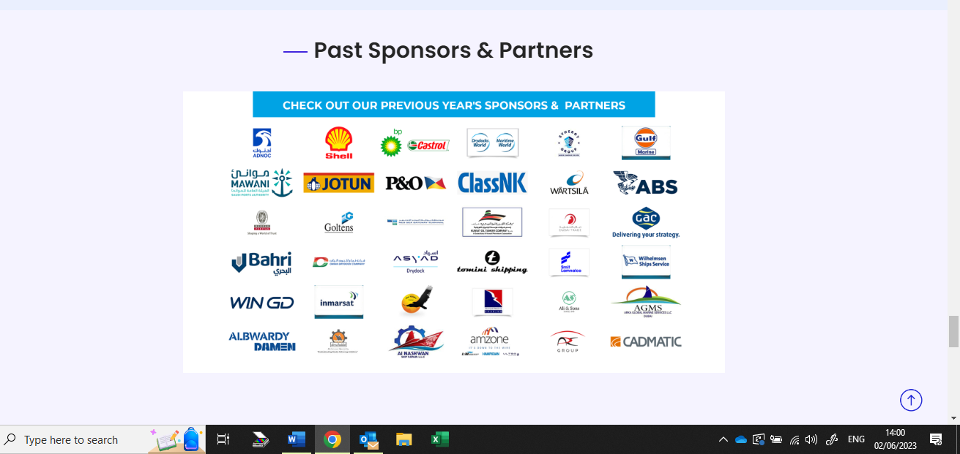use the same as above you have placed in ShipTek India Website.

Latest news and Blog section

Event location: Kingdom of Saudi Arabia (KSA)

